SIMATS ENGINEERING
SAVEETHA INSTITUTE OF MEDICAL AND TECHNICAL SCIENCES
CHENNAI – 602105

Department of Computer Science and Engineering

ASSESSMENT TOOL 1 – DEIGN AND CONNECTIVITY
Course Code: | DSA05 | Course Title: | Query Processing for Data  Science With Real Time  Applications
CO  Assessed: | CO2 | Assessment: | Tool 1 – DEIGN AND CONNECTIVITY
Weightage: |  | Total Marks: | 40 Marks
CO2 Statement: Use Python basics and SQL libraries to connect to databases SQLite, MySQL, PostgreSQL and perform CRUD operations like Create, Read, Update, Delete. (BTL6)
Student Name: |  | Reg. No.:
Section / Batch: |  | Date of  Submission:
Faculty Incharge: | Dr. B.SHYAMALA GOWRI | Project Mode: | Individual Submission

Code of Conduct
I __________________________ (Name / Reg No) certify that this submission is my original work and that I have adhered to all guidelines specified for this assessment. I understand that any violation of academic integrity rules will result in disciplinary action.
Signature: _________________________
Requirement  Analysis  (5 Marks) | ER Diagram  Design  (10 Marks) | Table Design &  Normalization (5 Marks) | Database Connectivity using Python  (20 Marks) | CRUD  Operations  (5 Marks) | Total  (35 Marks)
Scenario 1: University Student Management System
1. Requirement Analysis
Functional Requirements
S.No | Functional Requirement
1 | System shall store student, faculty, department and course details.
2 | Students shall be able to register for multiple courses.
3 | A course shall support enrollment of multiple students.
4 | System shall record faculty-course teaching assignments per semester.
5 | System shall maintain attendance records for each enrolled student.
6 | System shall store and retrieve examination results per student per course.
7 | System shall generate department-wise student strength reports.
8 | System shall generate faculty workload reports.
9 | System shall support CRUD operations on all core records.
Non-Functional Requirements
S.No | Non-Functional Requirement
1 | Data consistency across departments must be ensured (avoid duplicate IDs).
2 | System shall respond to queries within acceptable time for report generation.
3 | Database shall be normalized to minimize redundancy.
4 | System shall be portable using SQLite for lightweight deployment.
5 | Access to student and examination data shall be controlled.
2. ER Diagram
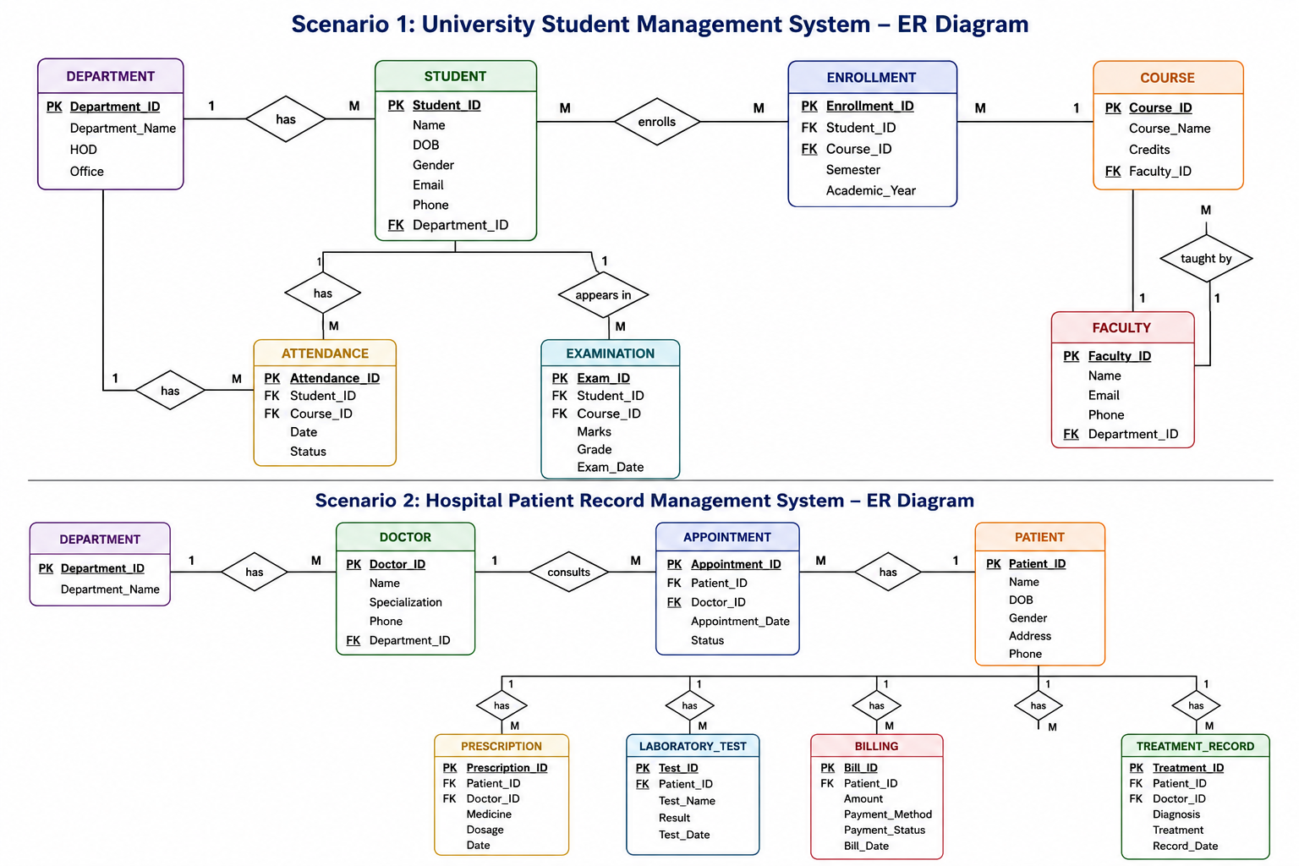
The ER model centers on Student and Course connected via an Enrollment associative entity (M:N). Faculty teaches Course (1:M) and belongs to Department (M:1). Attendance and Examination reference Enrollment to tie records to a specific student-course pairing.
3. Database Design & Normalization
Entities
Entity | Description
Department | Academic department offering courses.
Student | Enrolled student record.
Faculty | Teaching staff member.
Course | Course offered by a department.
Enrollment | Association of a student to a course with faculty.
Attendance | Attendance record per enrollment per date.
Examination | Examination result per enrollment.
Attributes
Entity | Attribute | Data Type | PK/FK
Department | dept_id | INTEGER | PK
Department | dept_name | TEXT | -
Student | student_id | INTEGER | PK
Student | name | TEXT | -
Student | dept_id | INTEGER | FK
Faculty | faculty_id | INTEGER | PK
Faculty | name | TEXT | -
Faculty | dept_id | INTEGER | FK
Course | course_id | INTEGER | PK
Course | course_name | TEXT | -
Course | dept_id | INTEGER | FK
Enrollment | enroll_id | INTEGER | PK
Enrollment | student_id | INTEGER | FK
Enrollment | course_id | INTEGER | FK
Enrollment | faculty_id | INTEGER | FK
Attendance | attendance_id | INTEGER | PK
Attendance | enroll_id | INTEGER | FK
Attendance | att_date | TEXT | -
Attendance | status | TEXT | -
Examination | exam_id | INTEGER | PK
Examination | enroll_id | INTEGER | FK
Examination | marks | REAL | -
Relationships
Entity 1 | Relationship | Entity 2 | Cardinality
Department | offers | Course | 1:M
Department | employs | Faculty | 1:M
Department | has | Student | 1:M
Student | enrolls in | Course | M:N (via Enrollment)
Faculty | teaches | Course | 1:M
Enrollment | generates | Attendance | 1:M
Enrollment | generates | Examination | 1:1
Normalization
1NF: All attributes hold atomic, single-valued data (e.g., student name and ID stored separately, no repeating groups).
2NF: All non-key attributes fully depend on the whole primary key; associative entities (Enrollment) remove partial dependency issues from composite relations.
3NF: No transitive dependency exists; e.g., dept_name depends only on dept_id, not indirectly through Student or Course.
4. Python Database Connectivity
Database Used: SQLite
Required Libraries: sqlite3 (built-in Python library)
Connection Code
import sqlite3
conn = sqlite3.connect("university.db")
cursor = conn.cursor()
cursor.execute("PRAGMA foreign_keys = ON")
conn.commit()
The sqlite3 module creates/connects to university.db, and a cursor object executes SQL statements. Foreign key enforcement is enabled via PRAGMA.
5. CRUD Operations
5.1 Create
SQL Query:
INSERT INTO Student (student_id, name, dept_id)
VALUES (101, 'Ishu Kumar', 1);
Python Code:
cursor.execute(
"INSERT INTO Student (student_id, name, dept_id) VALUES (?, ?, ?)",
(101, "Ishu Kumar", 1)
)
conn.commit()
Expected Output:
1 row inserted into Student table successfully.
5.2 Read
SQL Query:
SELECT student_id, name, dept_id FROM Student;
Python Code:
cursor.execute("SELECT student_id, name, dept_id FROM Student")
for row in cursor.fetchall():
print(row)
Expected Output:
(101, 'Ishu Kumar', 1)
[Insert Screenshot Here]
5.3 Update
SQL Query:
UPDATE Student SET dept_id = 2 WHERE student_id = 101;
Python Code:
cursor.execute(
"UPDATE Student SET dept_id = ? WHERE student_id = ?",
(2, 101)
)
conn.commit()
Expected Output:
1 row updated. dept_id changed to 2 for student_id 101.
5.4 Delete
SQL Query:
DELETE FROM Student WHERE student_id = 101;
Python Code:
cursor.execute("DELETE FROM Student WHERE student_id = ?", (101,))
conn.commit()
Expected Output:
1 row deleted from Student table.
Scenario 2: Hospital Patient Record Management System
1. Requirement Analysis
Functional Requirements
S.No | Functional Requirement
1 | System shall store patient, doctor and appointment details.
2 | A patient shall be able to consult multiple doctors over time.
3 | A doctor shall consult multiple patients.
4 | System shall link prescriptions and lab tests to specific patient visits.
5 | System shall record billing/payment details per appointment.
6 | System shall provide quick retrieval of complete patient history.
7 | System shall generate reports on disease trends and doctor workload.
8 | System shall support CRUD operations on all core records.

Non-Functional Requirements

S.No | Non-Functional Requirement
1 | Patient data must remain consistent and accurate across visits.
2 | System shall retrieve patient history with minimal query time.
3 | Database shall be normalized to avoid redundant patient/doctor data.
4 | System shall use SQLite for lightweight, portable deployment.
5 | Sensitive patient data access shall be restricted appropriately.

2. ER Diagram
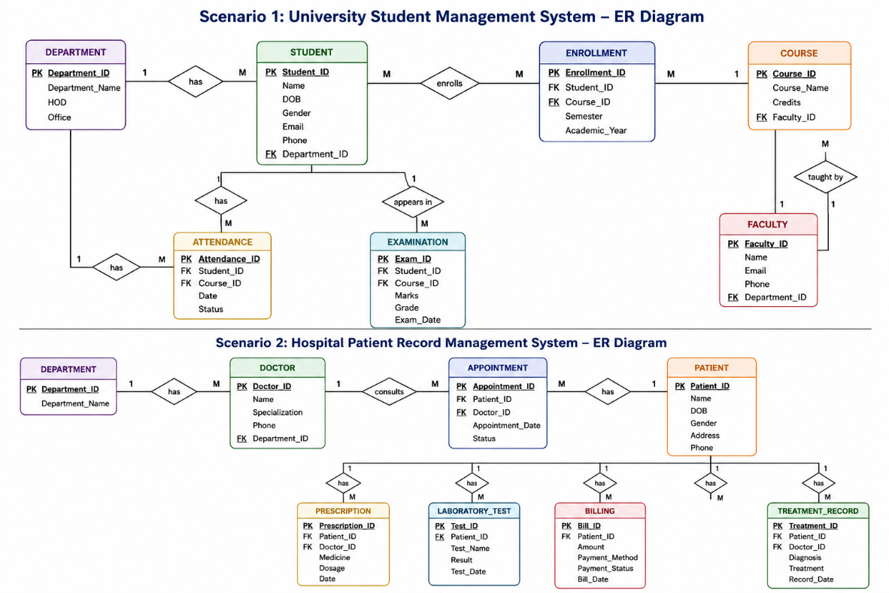Patient and Doctor connect via an Appointment associative entity (M:N). Each Appointment links to Prescription and LabTest (1:M) and to a Billing record (1:1), enabling full traceability of a patient visit.
3. Database Design & Normalization
Entities
Entity | Description
Patient | Individual receiving hospital care.
Doctor | Medical practitioner providing consultation.
Appointment | A patient-doctor consultation event.
Prescription | Medication prescribed during an appointment.
LabTest | Laboratory test ordered during an appointment.
Billing | Payment record for an appointment.
Attributes
Entity | Attribute | Data Type | PK/FK
Patient | patient_id | INTEGER | PK
Patient | name | TEXT | -
Patient | age | INTEGER | -
Doctor | doctor_id | INTEGER | PK
Doctor | name | TEXT | -
Doctor | specialization | TEXT | -
Appointment | appointment_id | INTEGER | PK
Appointment | patient_id | INTEGER | FK
Appointment | doctor_id | INTEGER | FK
Appointment | appt_date | TEXT | -
Prescription | prescription_id | INTEGER | PK
Prescription | appointment_id | INTEGER | FK
Prescription | medicine | TEXT | -
LabTest | test_id | INTEGER | PK
LabTest | appointment_id | INTEGER | FK
LabTest | test_name | TEXT | -
LabTest | result | TEXT | -
Billing | bill_id | INTEGER | PK
Billing | appointment_id | INTEGER | FK
Billing | amount | REAL | -
Billing | payment_status | TEXT | -
Relationships
Entity 1 | Relationship | Entity 2 | Cardinality
Patient | consults | Doctor | M:N (via Appointment)
Appointment | results in | Prescription | 1:M
Appointment | results in | LabTest | 1:M
Appointment | generates | Billing | 1:1
Normalization
1NF: All attributes are atomic; e.g., patient name and age stored as single-valued fields with no repeating groups.
2NF: Non-key attributes depend on the whole key; the Appointment associative entity eliminates partial dependency between patients and doctors.
3NF: No transitive dependency; e.g., specialization depends only on doctor_id, not through Appointment or Patient.
4. Python Database Connectivity
Database Used: SQLite
Required Libraries: sqlite3 (built-in Python library)
Connection Code
import sqlite3
conn = sqlite3.connect("hospital.db")
cursor = conn.cursor()
cursor.execute("PRAGMA foreign_keys = ON")
conn.commit()
The sqlite3 module connects to hospital.db, and the cursor executes SQL queries. PRAGMA foreign_keys enforces referential integrity between tables.
5. CRUD Operations
5.1 Create
SQL Query:
INSERT INTO Patient (patient_id, name, age)
VALUES (201, 'Ravi Shankar', 45);
Python Code:
cursor.execute(
"INSERT INTO Patient (patient_id, name, age) VALUES (?, ?, ?)",
(201, "Ravi Shankar", 45)
)
conn.commit()
Expected Output:
1 row inserted into Patient table successfully.
[Insert Screenshot Here]
5.2 Read
SQL Query:
SELECT patient_id, name, age FROM Patient;
Python Code:
cursor.execute("SELECT patient_id, name, age FROM Patient")
for row in cursor.fetchall():
print(row)
Expected Output:
(201, 'Ravi Shankar', 45)
5.3 Update
SQL Query:
UPDATE Patient SET age = 46 WHERE patient_id = 201;
Python Code:
cursor.execute(
"UPDATE Patient SET age = ? WHERE patient_id = ?",
(46, 201)
)
conn.commit()
Expected Output:
1 row updated. age changed to 46 for patient_id 201.
[Insert Screenshot Here]
5.4 Delete
SQL Query:
DELETE FROM Patient WHERE patient_id = 201;
Python Code:
cursor.execute("DELETE FROM Patient WHERE patient_id = ?", (201,))
conn.commit()
Expected Output:
1 row deleted from Patient table.

